FOIDOCH INSTRUCTIONS

FOIDOCH will offer you information on the status of purchase request. You will need to know one of three things to use it: purchase order number, invoice number or check number. With this information access FOIDOCH as follows:

- Type FOIDOCH (enter)
- Type one of the following:
  - PO (Alpha, not P zero)
  - INV
  - CHK (all check numbers begin with two zeros)
3. Tab
4. Type the corresponding number (i.e., PO # P0302004) Next Block (Ctrl Page Down)

This will fill in the information in reference to this document number. Your Screen should look like the following:

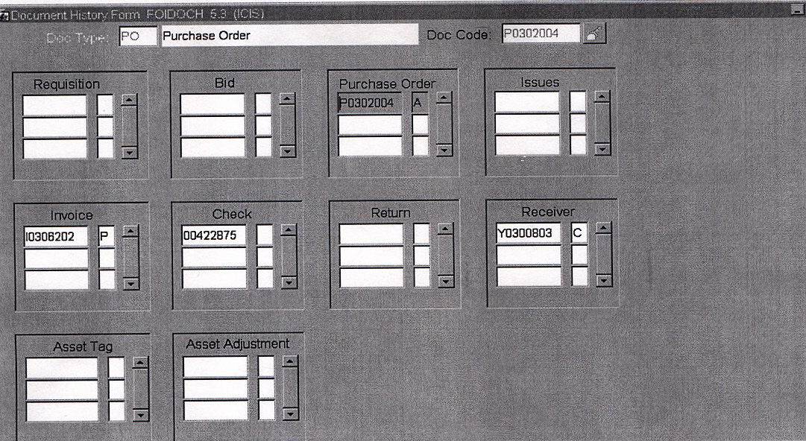

Within the Document History Form you can get additional information.

PURCHASE ORDER

- Click on the Purchase Order number
- Click Options
- Click Purchase Order Information
- Next Block (Ctrl Page Down)
Purchase/Blanket Order Inquiry: Document Information page shows you who the buyer is, the date the purchase order was typed, the date the purchase order was printed.

- Next Block (Ctrl Page Down)
Purchase/Blanket Order Inquiry: Requestor/Delivery page shows who the requestor was and the ship to address.
- Next Block (Ctrl Page Down)
Purchase/Blanket Order Inquiry: Vendor page shows the Vendor and their address.
- Next Block (Ctrl Page Down)
Purchase/Blanket Order Inquiry: Commodity/Accounting page shows the items ordered and the budget charged.
- Exit (Ctrl Q)
- Click Options
- Click View Status Indicator
This shows you what the letter following the PO means (i.e, X=cancelled)
11. Click Cancel on Status Indicator to return to the FOIDOCH screen

You can Exit (Ctrl Q) at anytime to return to the FOIDOCH screen.

RECEIVING

- Click on Receiving
- Click Options
- Click Receiver Information
- Next Block (Ctrl Page Down)
Receiving Goods Query Form shows you the date that the Green Copy was received by Purchasing. It is then passed to accounts payable the next working day.
- Exit (Ctrl Q)

You can Exit (Ctrl Q) at anytime to return to the FOIDOCH screen.

INVOICE

- Click on the Invoice Number
- Click Options
- Click Invoice Information
- Next Block (Ctrl Page Down)
Invoice/Credit Memo Query page shows you the vendor being paid. The Invoice/Credit Memo Header page shows the vendor’s address, the date of the invoice, and the transaction date (date accounts payable entered information into the system), payment due date (date the check will be printed, it will be processed the next working day).
- Click Options
- Click Document Text
- Next Block (Ctrl Page Down)
General Text Entry Form tells you the instructions for check distribution. (ASAP will be mailed immediately, DISC will be mailed immediately, DATE will be mailed according to date instructed to mail on, EXT a GU ext will be called.)
8. Exit (Ctrl Q)

9. Next Block (Ctrl Page Down)
Commodity/Information – Regular page shows you what was paid on this invoice. Use the ↑ ↓ to move from one item to the next.
- Next Block (Ctrl Page Down)
Accounting Amounts page shows the net which is the total amount paid on this
invoice.
- Click Options
- Click Accounting Distribution Information
Accounting Distribution screen shows you what budget was used
- Exit (Ctrl Q)
- Click Options
- Click View Status Indicator
This shows you what the letter following the Inv means (i.e, P=paid)
16. Click Cancel on Status Indicator to return to FOIDOCH.

You can Exit (Ctrl Q) at anytime to return to the FOIDOCH screen.

CHECK

- Click on Check
- Click on Options
- Click on Check Information
- Tab Once and make sure the Bank is US, if not Type US
- Next Block (Ctrl Page Down)
Check Payment History Form tells you the check date, the invoice number(s), and amount(s) paid.
NOTE: One check can be used to cover numerous transactions. To confirm which invoice is related to your transaction, click on the invoice number. Click Options, Click Document Inquiry, Next Block (Ctrl Page Down), the Invoice/Credit Memo Query Form will show you what PO was connected to the invoice. Exit (Ctrl Q).
- Exit (Ctrl Q)
- Click Options
- Click View Status Indicator
This shows you what the letter following the Chk means (i.e, F=final reconciliation and has been cleared by the bank)
- Click Cancel on Status Indicator

You can Exit (Ctrl Q) at anytime to return to the FOIDOCH screen.

